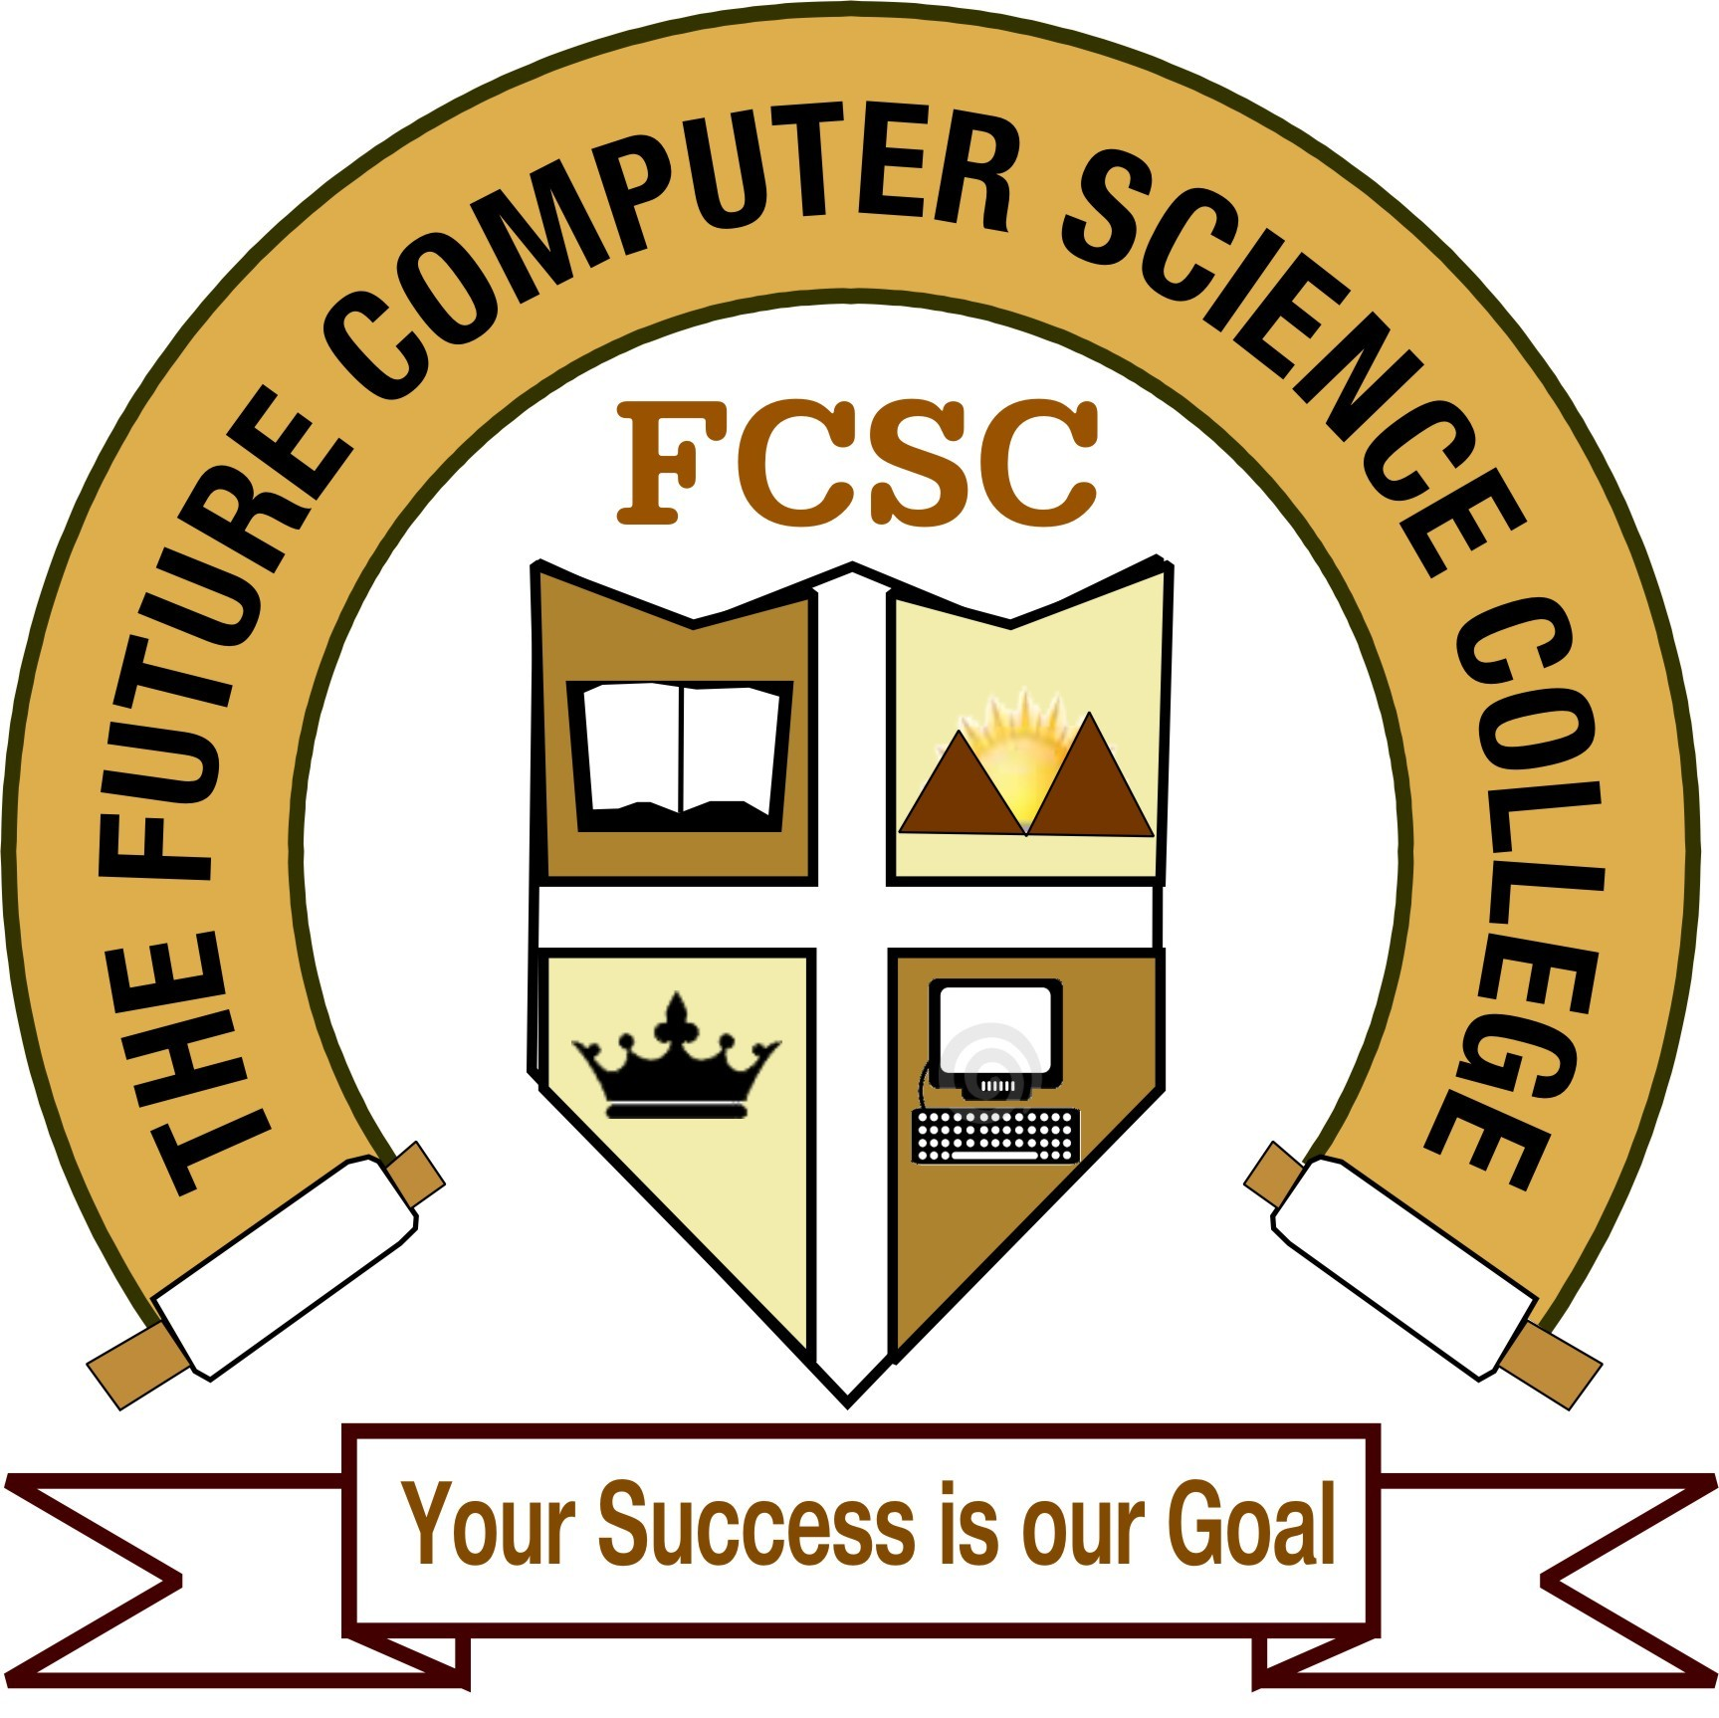

The Future Computer Science College
Junagadh

Project Completion Certificate
(2014-15)

This is to certify that Miss. ZATAKIYA KRISHNA and Miss.KANERIYA MITAL has successfully completed the project work on RETAIL FURNITURE as partial fulfillment of the requirements of the degree of Bachelor of Computer Application in Saurashtra University Rajkot.

Date:

_________ _____________ __________
Principal Internal Guide Examiner

